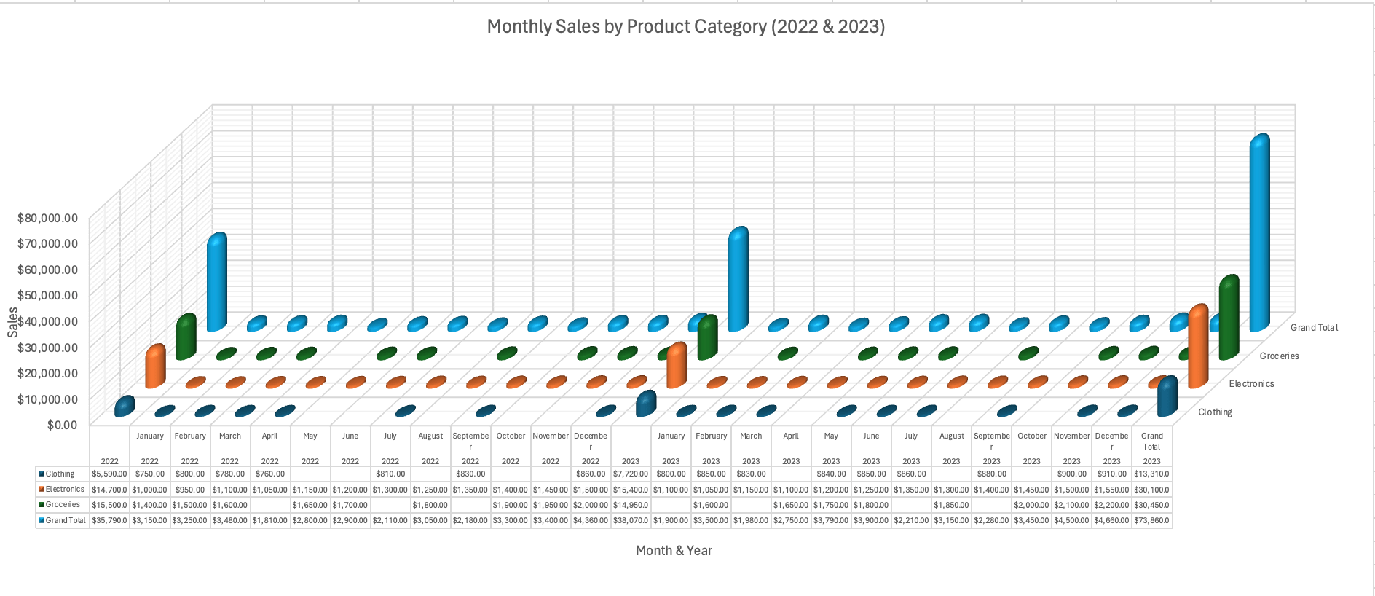

*Fig 1: Anti-Minimal plot*

The original 3D plot looks fancy but is confusing. It combines monthly and annual sales, which obscures trends, and the 3D effect adds unnecessary complexity. The gridlines create noise, and the lack of a legend makes interpretation difficult, even though categories are listed on the right. The revised plot is simpler and more intuitive, making it easier to understand at a glance.

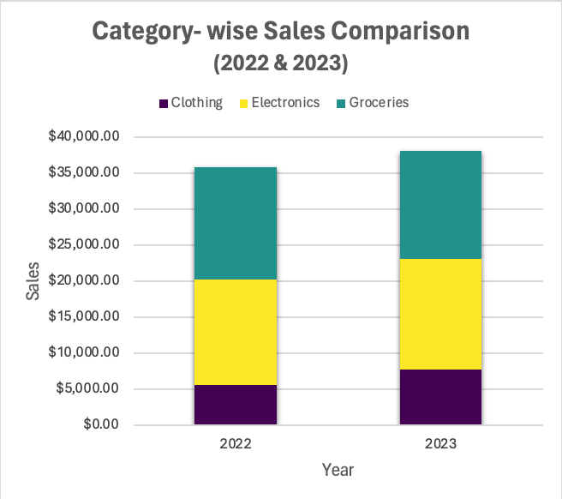

*Fig 2: Annual Sales*

This chart focuses on the totals per year and gives us information of the total sale for the year as well as the breakdown of categories for that year. Considering the temporal information, we can investigate what the sales were each month with the plot attached.

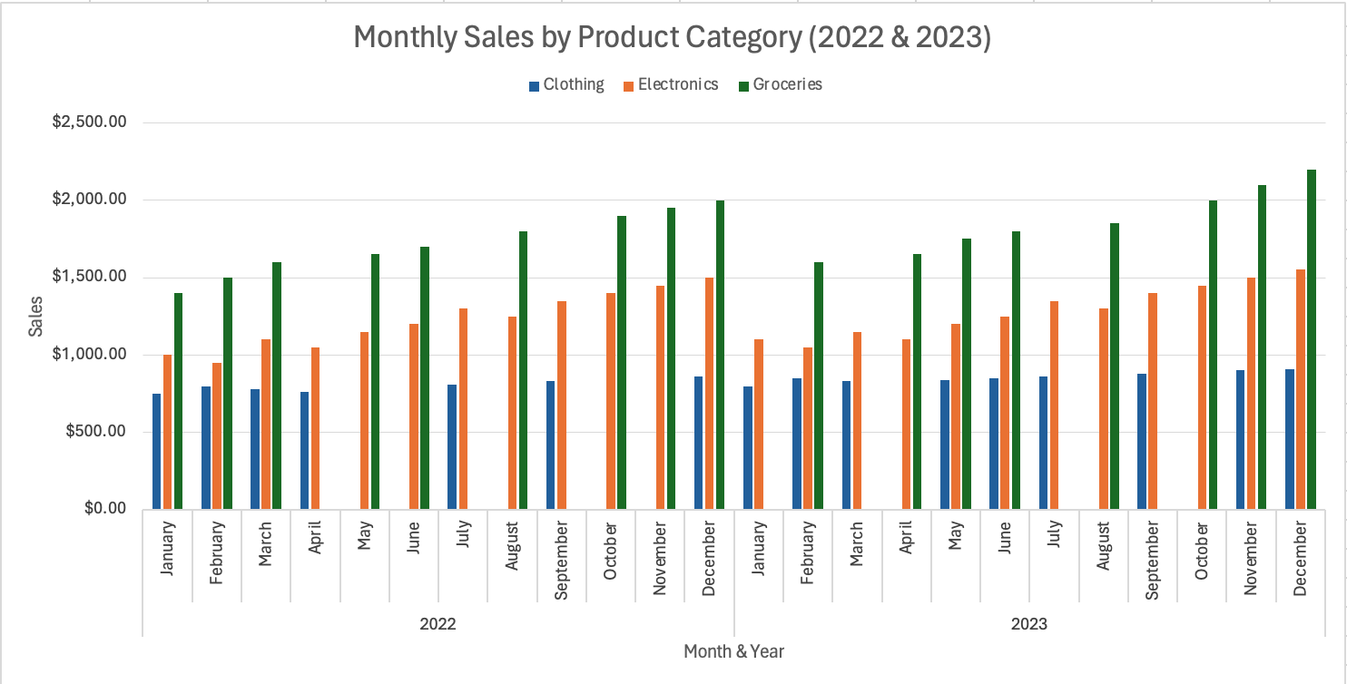

*Fig 3: Monthly Sales*

To check if sales have increased in any category over two years, we can use a grouped bar chart with categories on the x-axis and bars for each year within each category.